National Library of Scotland (NLS) - eResources

What they are
Registering with the Library gives you free access to a wide range of eResources. Some of these may only be accessed in the Library’s reading rooms, but there are also many which you can use at home by logging into our website using your email address and Library password. The Library subscribes to these resources to enable us to offer them to our registered users (though some restrictions do apply).
NLS eResources cover many subjects, from history and social sciences to newspapers and business. You will find them by clicking this link https://auth.nls.uk/eresources/ or by going to NLS website and follow steps below:
How to register
• Go to NLS website and click the orange join/login button
• This takes you to https://auth.nls.uk/join/ - fill out the registration form
• Check your email inbox for the link to create a password and click on this
• Create your password
• Log in and discover our eResources

How to find them
NLS currently subscribes to over 100 eResources which cover a wide variety of subjects, and there are different ways in which you can search these:
• Browse by title, the easiest way if you already know which eResource you need:
https://auth.nls.uk/eresources/browse/title
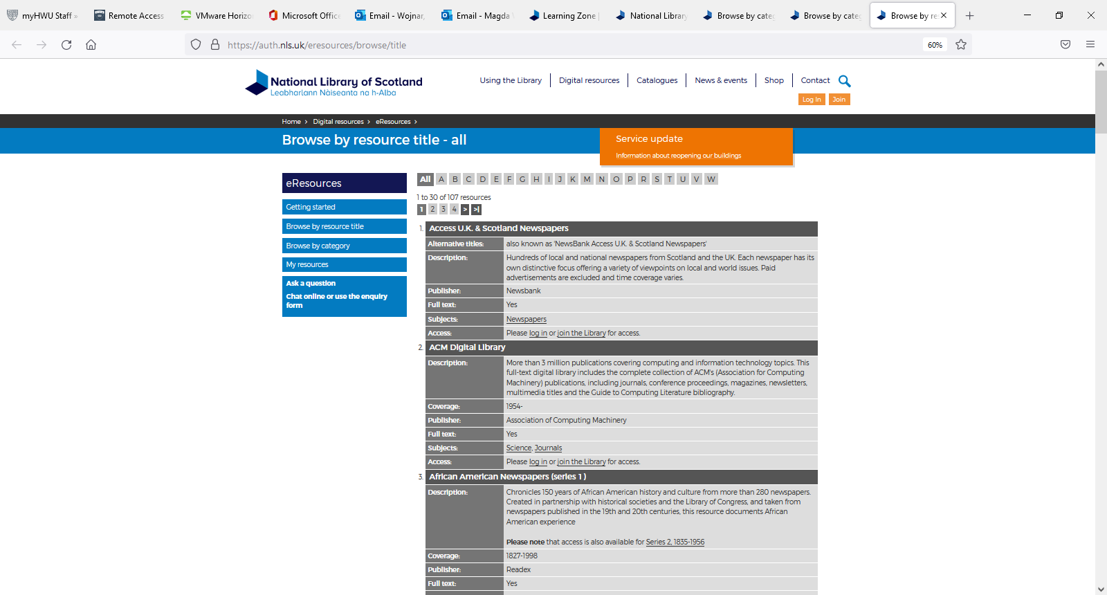

• Browse by subject, using the handy subject lists and resource descriptions to identify which are most useful: https://auth.nls.uk/eresources/browse/subject
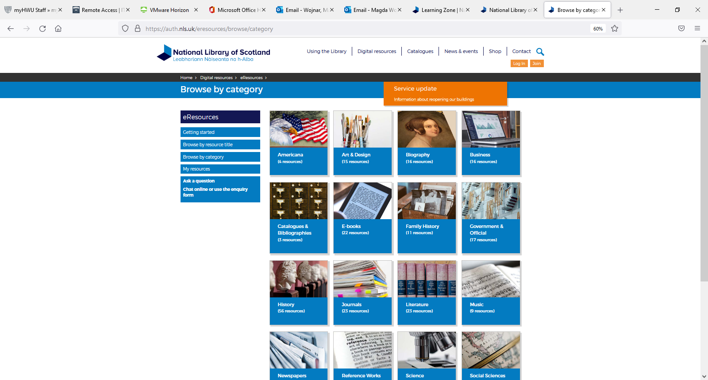

• LibrarySearch, choose to search “Everything”: https://search.nls.uk/
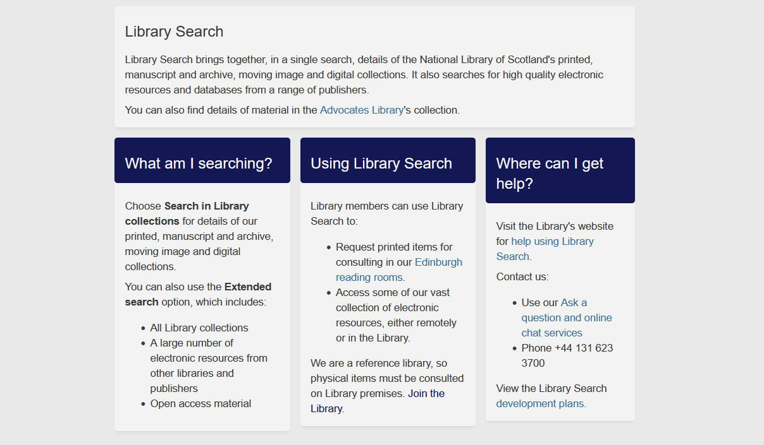

Remember that you can store links to your favourite eResources under My resources:
https://auth.nls.uk/eresources/browse/my_resources

You can narrow your search results by selecting document type:

There are various save options:

Once you open database, you can do Advance Search:
Difficulties to search – please get in touch
As there are so many eResources, it is impossible to describe how to search within each one. However many of them have a simple search box in common, where you can enter keywords and then refine your search by date/subject/etc. The best way to become familiar with these is simply to try different searches and note which ones work best. If you are struggling then please contact your school librarian or NLS team below:
E-mail: enquiries@nls.uk
Ask A Librarian: https://www.nls.uk/contact/ask-a-librarian
Chat: https://www.nls.uk/chat/ (open 10am to 4pm, Monday to Friday)
Useful eResources and links accessible via NLS:
Please remember to log in (https://auth.nls.uk/login/) before accessing the resources below:
- Scotsman Digital Archive, 1817-1950: https://auth.nls.uk/eresources/goto/115
- Springerlink journal and ebook collection: https://auth.nls.uk/eresources/goto/175
- Access U.K. & Scotland newspapers: https://auth.nls.uk/eresources/goto/266

- https://www.nls.uk/learning-zone/

